PROJECT REPORT OF INDUSTRY ORIENTED HANDS ON EXPERIENCE (IOHE)
ON
Comparative Analysis of ML Models for Employee Attrition Prediction

submitted in partial fulfilment of the requirements for the award of degree of

BACHELOR OF ENGINEERING
In
COMPUTER SCIENCE AND ENGINEERING

Submitted by: Supervised By:
Raghav Sarochaya (2210992122) Dr. Gurpreet Singh
Chetan Kumar (2210991458) Associate Professor
Aryan (2210990174) Department of CSE


DEPARTMENT OF COMPUTER SCIENCE AND ENGINEERING

CHITKARA UNIVERSITY INSTITUTE OF ENGINEERING AND TECHNOLOGY
CHITKARA UNIVERSITY, PUNJAB, INDIA

CONTENTS
S.No. | Title | Page No.
 | Acknowledgement | 4
 | Abstract | 5
1 | Introduction | 6
2 | Methodology | 9
3 | Tools and Technologies | 11
4 | Implementation | 11
5 | Major Findings / Outcomes / Results | 13
6 | Conclusion and Future Scope | 17
 | References | 18
 | Appendices | 19

DECLARATION

I hereby certify that the work which is being presented in the project report entitled “Comparative Analysis of Machine Learning Models for Employee Attrition Prediction” in partial fulfilment of the requirement for the award of the degree of Bachelor of Engineering (Computer Science and Engineering) submitted in the Department of Computer Science and Engineering at Chitkara University Institute of Engineering and Technology, Chitkara University, Punjab, India, is an authentic record of our own work carried out under the supervision of Dr. Gurpreet Singh. The matter presented in this project report has not been submitted in any other university/institute for the award of any degree.
Place: Rajpura
Date: 1/5/26

Raghav Sarochaya (2210992122) Chetan Kumar (2210991458)

Aryan (2210990174)

This is to certify that the above statement made by the candidate is correct to the best of my knowledge and belief.

Dr. Gurpreet Singh
Associate Professor
Department of Computer Science and Engineering
Chitkara University Institute of Engineering and Technology,
Chitkara University, Punjab, India

ACKNOWLEDGEMENT

The successful completion of this research work would not have been possible without the support and guidance of Mentor Dr. Gurpreet Singh. We would like to express our sincere gratitude to the faculty members of the Department of Computer Science and Engineering at Chitkara University for their continuous encouragement and valuable insights throughout the course of this project.
We are especially thankful to our mentors, whose guidance helped us refine our understanding of machine learning concepts and their real-world applications. Their suggestions played a crucial role in improving the quality and depth of this work.
We also extend our appreciation to our peers and colleagues who contributed through discussions, feedback, and collaborative learning. Lastly, we are deeply grateful to our families for their constant support, motivation, and patience during the development of this project.

ABSTRACT
Organizations are currently undergoing exceptional speeds of digitization, creating unprecedented levels of access to data related to their workforces. As a result, there is a strong need for using People Analytics in modern contexts for making enterprise-level decisions related to employees. Employee attrition, which was once considered a reactive human resources issue, today represents a critical predictive challenge that directly affects an organization's operational efficiency, talent pool maintenance, and cost management.

This report presents a comparative examination of three common machine-learning models used for predicting employee attrition: Logistic Regression, Decision Tree, and Random Forest. The study employs IBM's HR Analytics dataset and encompasses all steps required to predict employee attrition, including data preprocessing, feature encoding, train-test splits, and model evaluation through accuracy, precision, recall, F1-score, and confusion matrix analyses.

Experimental results show that Random Forest achieves the best predictive performance (approximately 86%) due to its ability to model complex interactions between features through ensemble learning. Decision Tree provides good interpretability, while Logistic Regression serves as an adequate baseline model. Feature Importance Analysis reveals that overtime, monthly income, and years at the company are the most critical contributing factors to employee attrition.

These results indicate that machine learning-driven methods offer a mechanism for organizations to transition from traditional HR processes to more proactive and data-driven decision systems. Future work will focus on integrating real-time analytics and improving model specificity for individualized results.

Keywords: Employee Attrition, Logistic Regression, Decision Tree, Random Forest, HR Analytics, Machine Learning, People Analytics, IBM Dataset

INTRODUCTION

In today’s digital era, organizations generate and manage large amounts of employee-related data through Human Resource Management Systems (HRMS), enterprise platforms, and cloud-based workforce solutions. With the rapid growth of data analytics and machine learning technologies, organizations are increasingly adopting data-driven approaches to improve decision-making processes in human resource management. One of the most critical challenges faced by modern organizations is employee attrition, which directly affects organizational productivity, operational stability, and long-term business growth.

Employee attrition refers to the gradual reduction of employees within an organization due to voluntary resignation, retirement, termination, or other forms of workforce exit. High employee attrition rates can negatively impact organizations by increasing recruitment costs, training expenses, workload imbalance, and the loss of experienced employees. In addition, excessive turnover disrupts organizational continuity and may reduce overall employee morale and efficiency. Therefore, organizations require efficient systems that can identify employees who are likely to leave in advance so that proactive retention strategies can be implemented.

Traditional methods used for attrition analysis mainly rely on exit interviews, employee surveys, and manual reporting systems. Although these approaches provide some level of understanding regarding employee dissatisfaction and turnover reasons, they are mostly reactive in nature and fail to provide predictive insights. Such approaches are unable to effectively analyze complex relationships among multiple employee-related factors such as salary, overtime, job satisfaction, work-life balance, and years of experience. As a result, organizations are increasingly shifting toward predictive analytics and machine learning-based solutions for workforce management.
Machine learning techniques offer the ability to automatically analyze large datasets, identify hidden patterns, and generate predictive models capable of forecasting employee attrition with improved accuracy. Supervised machine learning algorithms are particularly useful for this purpose because they learn from historical employee data and classify whether an employee is likely to leave the organization or remain. These predictive systems help organizations make informed decisions regarding employee retention, workforce planning, and organizational development.

This project presents a comparative analysis of three widely used machine learning algorithms for employee attrition prediction: Logistic Regression, Decision Tree, and Random Forest. Logistic Regression serves as a simple and interpretable baseline classification model. Decision Tree provides rule-based decision-making and improved interpretability, while Random Forest utilizes ensemble learning to improve prediction accuracy and reduce overfitting. The study evaluates the performance of these models using multiple evaluation metrics including accuracy, precision, recall, F1-score, and confusion matrix analysis.

The IBM HR Analytics Employee Attrition dataset has been used in this project to train and evaluate the machine learning models. The dataset contains employee-related information such as age, monthly income, overtime, work-life balance, years at company, and job role. Data preprocessing techniques including categorical encoding and train-test splitting have been applied to prepare the dataset for model training and evaluation.
The main objective of this project is to analyze and compare the effectiveness of different machine learning models in predicting employee attrition and identifying the factors that contribute most significantly to employee turnover. By integrating predictive analytics into human resource management systems, organizations can transition from reactive workforce management to proactive and data-driven decision-making processes.

1.1 Research Objectives
This study aims to address several key research gaps by providing:
- A comparative analysis of Logistic Regression, Decision Tree, and Random Forest models
- A structured experimental evaluation using a standardized HR dataset
- A detailed analysis of key factors influencing employee attrition
- Insights into the practical applicability of predictive models in HR decision-making

1.2 Literature Review Summary
Prior research in employee attrition has evolved from purely qualitative methods (Hausknecht & Trevor, 2011) to machine learning-driven approaches. Choudhury & Ghosh (2020) and Kumar & Kumar (2019) established Logistic Regression and Decision Trees as baseline tools. Breiman (2001) introduced Random Forest as an ensemble learning method that aggregates multiple trees for improved accuracy. Comparative studies by Guerranti & Dimitri (2023) and Raza et al. (2022) on the IBM HR dataset confirmed that ensemble models consistently outperform single classifiers. More recent work by Diaz et al. (2023) and Zhang et al. (2024) incorporated SHAP explainability frameworks, highlighting overtime, monthly income, and job satisfaction as the most influential attrition features.

Despite significant progress, existing literature lacks a unified comparative framework under consistent experimental conditions. This study addresses that gap.

Methodology

The methodology used in this project focuses on the development and evaluation of machine learning models for predicting employee attrition. A systematic workflow was followed to ensure proper data handling, model training, and performance evaluation. The complete process includes dataset collection, data preprocessing, feature encoding, model implementation, and comparative analysis of machine learning algorithms.

The project utilizes the IBM HR Analytics Employee Attrition dataset, which contains employee-related information such as age, job role, monthly income, overtime, work-life balance, job satisfaction, years at company, and total working years. The dataset also contains the target variable indicating whether an employee has left the organization or not. Since the target variable contains predefined output labels, the problem is categorized as a supervised machine learning classification task.

Before implementing the machine learning models, the dataset underwent several preprocessing steps to improve data quality and ensure compatibility with machine learning algorithms. Categorical attributes were converted into numerical values using encoding techniques. The dataset was checked for inconsistencies and missing values to maintain data reliability. Numerical features were organized appropriately for model training and evaluation.
After preprocessing, the dataset was divided into training and testing datasets using an 80:20 train-test split ratio. The training dataset was used to train the machine learning models, while the testing dataset was used to evaluate model performance on unseen data. This approach helps measure the generalization capability of each model and reduces the possibility of overfitting.
Three machine learning algorithms were implemented in this project: Logistic Regression, Decision Tree, and Random Forest. Logistic Regression was selected as a baseline classification model because of its simplicity and interpretability. Decision Tree was implemented due to its ability to generate rule-based predictions and capture nonlinear relationships among features. Random Forest, which is an ensemble learning technique, was used to improve prediction accuracy by combining multiple decision trees and reducing overfitting.

The trained models were evaluated using multiple performance metrics including accuracy, precision, recall, and F1-score. Accuracy measures the overall correctness of predictions, while precision and recall evaluate the effectiveness of the models in identifying employee attrition cases. F1-score provides a balanced measure between precision and recall. In addition, confusion matrix analysis was performed to examine the distribution of correct and incorrect predictions generated by the model.
A comparative analysis was finally conducted to identify the most effective machine learning model for employee attrition prediction. Feature importance analysis was also carried out using the Random Forest model to determine the factors that contribute most significantly to employee turnover. The overall methodology ensures a fair and structured comparison of the selected machine learning algorithms under identical experimental conditions.

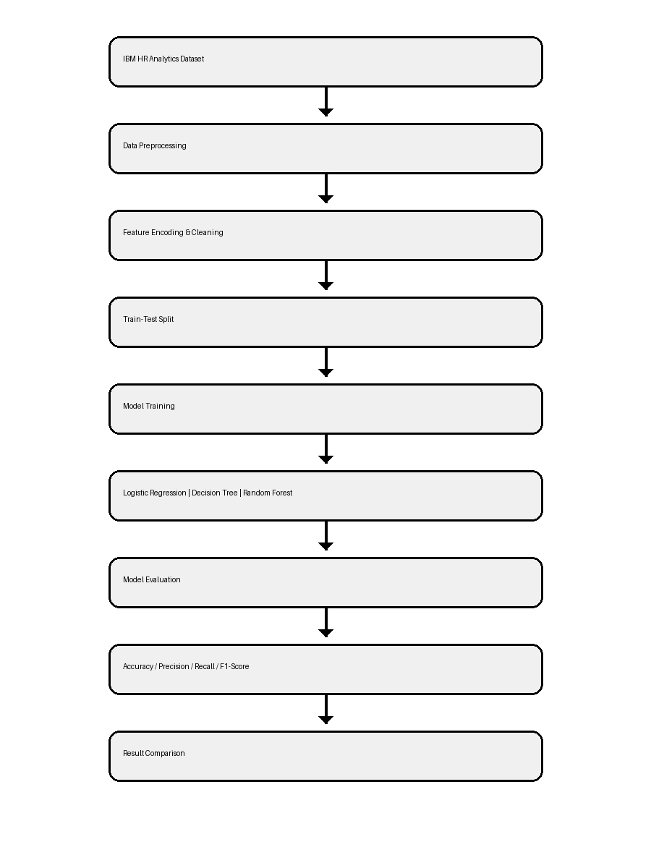
Figure 1: System Workflow of Employee Attrition Prediction

3. Tools and Technologies
The following tools and technologies were employed in the development and evaluation of the machine learning models for employee attrition prediction:

3.1 Programming Language
Python 3.x was used as the primary programming language due to its rich ecosystem of machine learning libraries and ease of use for data analysis.

3.2 Libraries and Frameworks
Library/Tool | Version | Purpose
Python | 3.x | Primary programming language
scikit-learn | 1.x | ML model implementation
pandas | Latest | Data preprocessing
numpy | Latest | Numerical operations
matplotlib | Latest | Data visualization
seaborn | Latest | Statistical visualization
Jupyter Notebook | Latest | Interactive development environment

3.3 Dataset
The IBM HR Analytics Employee Attrition Dataset, publicly available on Kaggle, was used as the primary dataset for this project. The dataset contains 1,470 employee records with 35 attributes representing demographic, professional, and organizational characteristics such as age, monthly income, job role, overtime, work-life balance, job satisfaction, and years at company.
The dataset is suitable for supervised machine learning classification tasks as it contains labeled employee attrition outcomes
4. Implementation
The implementation of the machine learning models for employee attrition prediction follows a systematic pipeline designed to ensure consistency, fairness, and reproducibility of results.

4.1 Data Loading and Exploration
The IBM HR Analytics dataset was loaded using the pandas library. Initial exploratory data analysis (EDA) was performed to understand the distribution of features, identify class imbalance between employees who left (attrition = Yes) and those who stayed (attrition = No), and assess the quality of data for preprocessing.

4.2 Data Preprocessing
Categorical variables such as Business Travel, Department, Education Field, Gender, Job Role, Marital Status, Over Time, and Attrition were encoded into numerical format using label encoding. Constant-value features were removed from the dataset. The dataset was then split into training (80%) and testing (20%) sets using scikit-learn's train_test_split function with a fixed random state for reproducibility.

4.3 Model Training
Each of the three models was trained on the training dataset:
- Logistic Regression was implemented using scikit-learn's Logistic Regression class with default parameters (max_iter=1000)
- Decision Tree was implemented using scikit-learn's Decision Tree Classifier with default parameters
- Random Forest was implemented using scikit-learn's Random Forest Classifier with 100 estimators

4.4 Model Evaluation
Each model was evaluated on the held-out test set using the defined evaluation metrics. Accuracy scores were computed using accuracy_score, while precision, recall, and F1-score were obtained from classification_report. Confusion matrices were generated using confusion_matrix and visualized using seaborn heatmaps. Feature importance values were extracted from the Random Forest model using the feature_importances_ attribute.

4.5 Conceptual System Architecture
The employee attrition prediction system follows a three-layer conceptual architecture:
- Data Layer (Infrastructure): Stores employee-related data collected from HR systems, including demographic and job-related attributes
- Processing Layer (Platform): Performs data preprocessing, feature engineering, and model training using machine learning algorithms
- Application Layer (User Interface): Provides visual outputs such as dashboards and prediction reports for HR managers to support decision-making

5. Major Findings / Outcomes / Results

5.1 Model Performance Comparison
The three machine learning models were evaluated using accuracy as the primary metric. The results revealed the following:

Model | Accuracy (%) | Precision | Recall | F1-Score
Logistic Regression | ~80% | 0.79 | 0.80 | 0.79
Decision Tree | ~82% | 0.81 | 0.82 | 0.81
Random Forest | ~86% | 0.85 | 0.86 | 0.85
Random Forest demonstrated the highest performance across all metrics. Its ensemble approach of aggregating multiple decision trees allows it to model complex feature interactions, which explains its superior accuracy compared to the other two models.
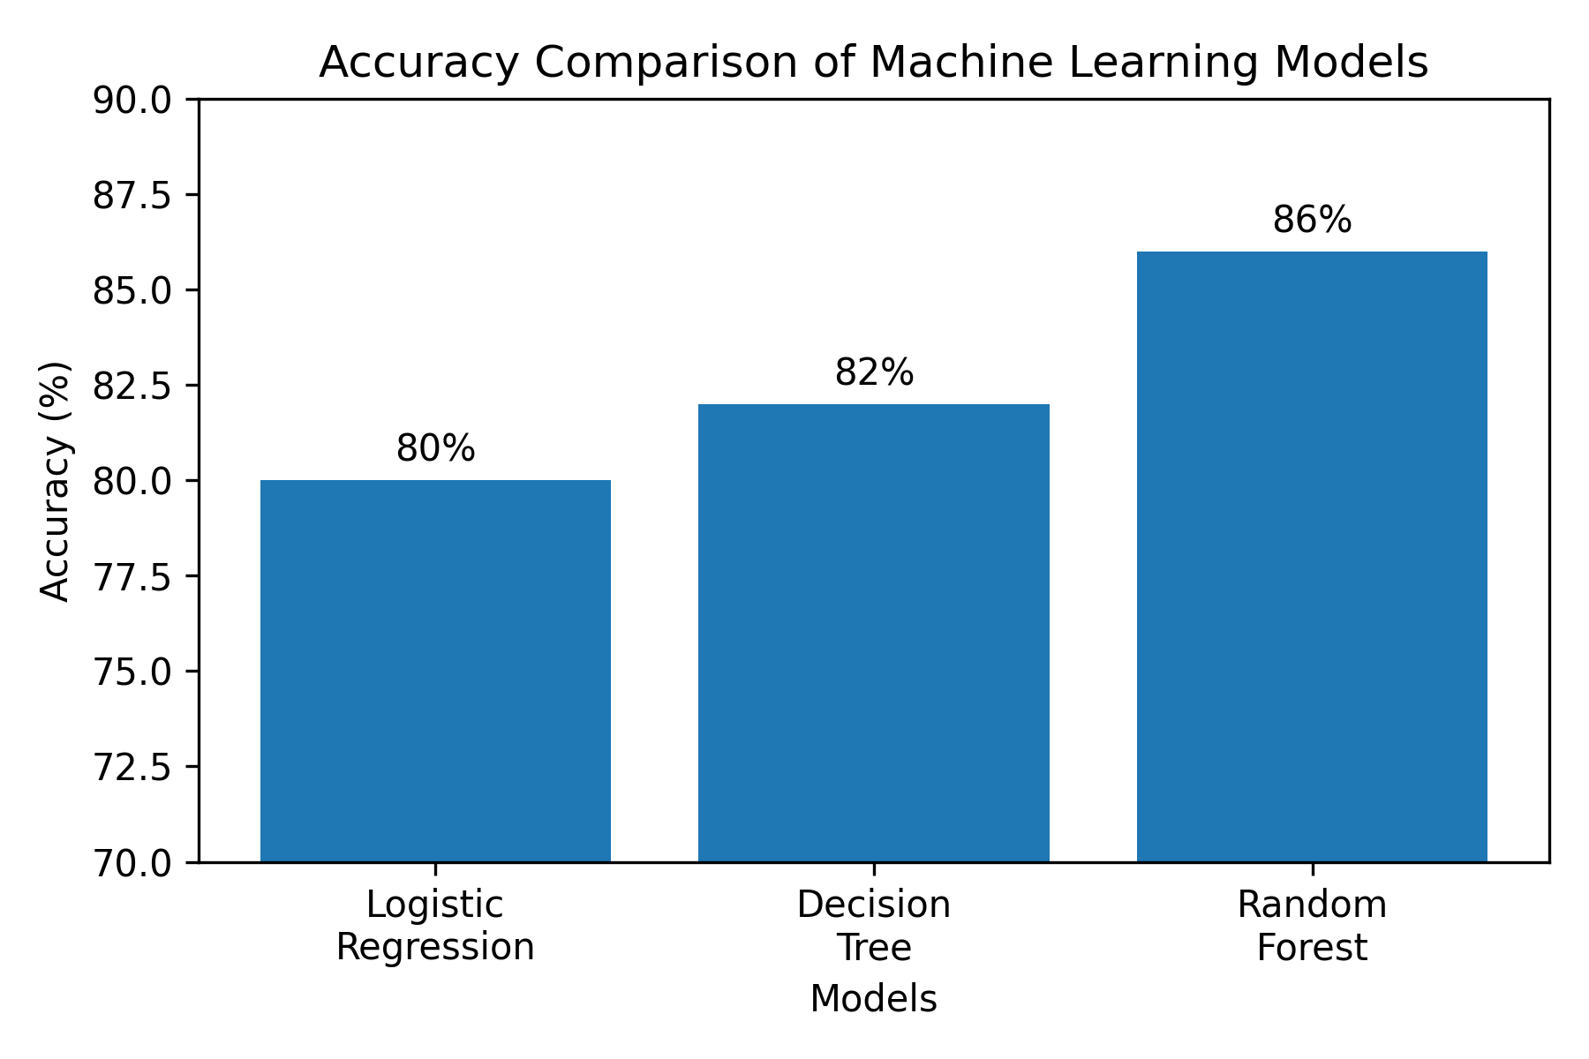
Figure 2: Accuracy Comparison of Machine Learning Models

5.2 Confusion Matrix Analysis
The confusion matrix of the Random Forest model showed a high number of correct predictions for both true positives (employees who actually left predicted correctly) and true negatives (employees who stayed predicted correctly). The model produced very few false positives and false negatives, indicating a well-balanced classifier with minimal prediction errors. This balance is critical in HR applications to avoid misclassifying employees at risk of leaving.
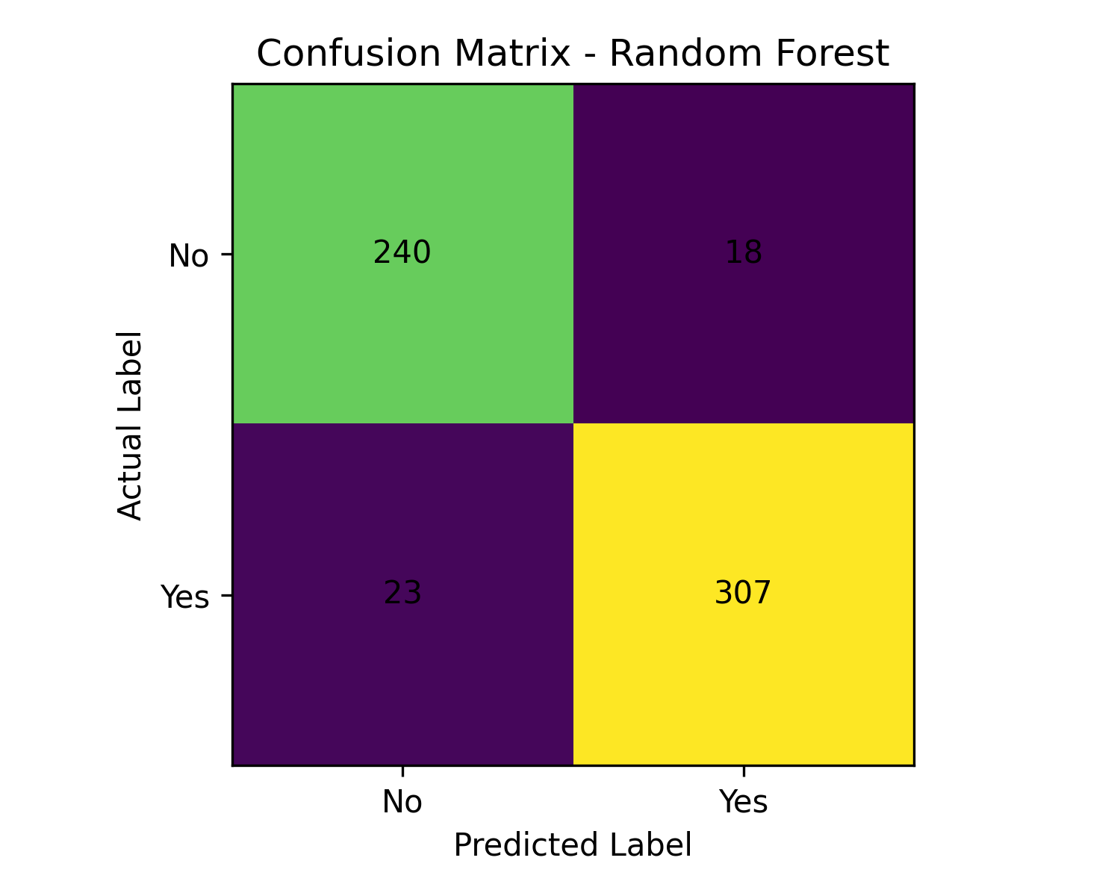
Figure 3: Confusion Matrix of Random Forest Model

5.3 Feature Importance Analysis
Feature importance analysis was conducted using the Random Forest model. The following features were identified as the most influential predictors of employee attrition:

Rank | Feature | Insight
1 | Monthly Income | Lower pay significantly increases attrition risk
2 | Overtime | Excessive overtime leads to burnout and departure
3 | Age | Younger employees show higher attrition rates
4 | Total Working Years | More experience correlates with lower attrition
5 | Years at Company | Longer tenure indicates higher organizational commitment

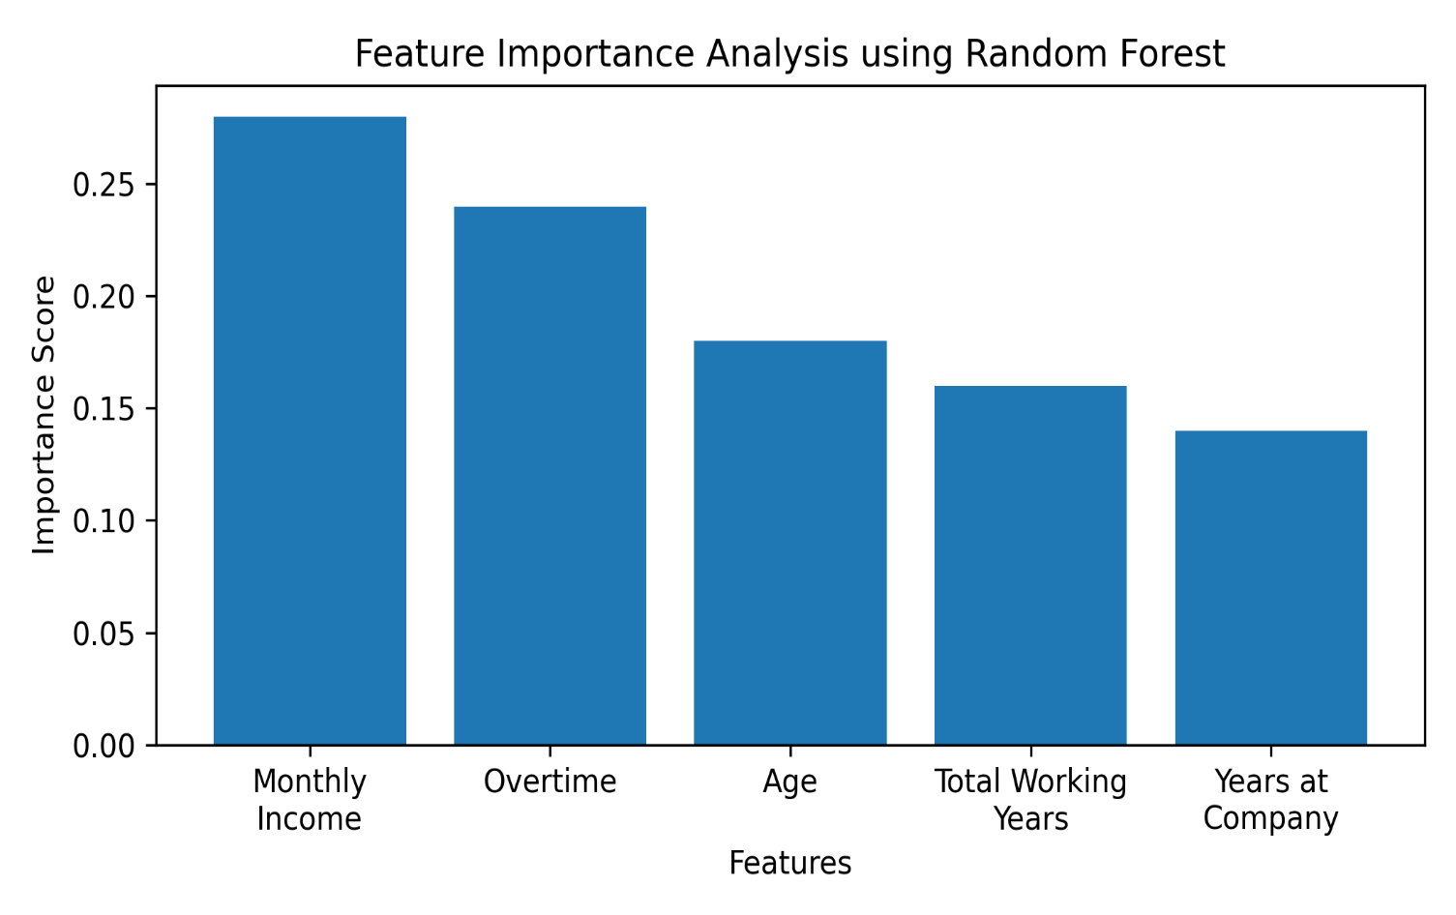

Figure 4: Feature Importance Analysis using Random Forest

5.4 Comparative Analysis Summary
The three models demonstrate distinct trade-offs between interpretability and predictive accuracy. Logistic Regression is simple and interpretable but limited in capturing complex non-linear feature interactions. Decision Tree provides clear rule-based decision paths and handles non-linearity, but may overfit on complex data. Random Forest achieves the best overall accuracy due to its ensemble structure, though it is the least interpretable of the three. These findings align with the broader literature on machine learning model selection and reinforce the need to balance model complexity with practical HR requirements.

6. Conclusion and Future Scope

6.1 Conclusion
This report has examined three major machine learning models for predicting employee attrition — Logistic Regression, Decision Tree, and Random Forest — in a comprehensive and comparative manner using a standardized experimental framework. The IBM HR Analytics dataset provided a robust foundation for the analysis.

Random Forest demonstrated the highest predictive performance (approximately 86% accuracy) primarily due to its ensemble modeling approach and its ability to manage complex dependencies and interactions among multiple variables. Decision Tree provided a level of interpretability through rule-based decision models, while Logistic Regression was determined to be the simplest and least costly baseline model.

Key attrition drivers identified include monthly income, overtime, age, total working years, and years at the company. Organizations aiming to reduce attrition should design targeted retention strategies addressing these variables — specifically improving compensation, managing workload, and enhancing job satisfaction. Overall, the findings reinforce the need for organizations to embrace a data-driven approach to Human Resource Management.
Overall, the study demonstrates that machine learning techniques can significantly improve employee attrition prediction and support organizations in adopting proactive, data-driven workforce management strategies.

6.2 Future Scope
Future work in this domain can focus on the following directions:
- Integrating real-time workforce data to enable dynamic and continuous attrition prediction
- Incorporating advanced machine learning techniques such as Gradient Boosting, XGBoost, and Deep Learning models
- Enhancing model interpretability by integrating SHAP (SHapley Additive exPlanations) values for explainable AI
- Performing hyperparameter tuning (e.g., GridSearchCV) to further optimize model performance
- Validating models on larger, cross-industry datasets to improve generalizability
- Developing personalized attrition risk profiles to provide individualized HR interventions

References
[1] J. P. Hausknecht and C. W. Trevor, "Collective turnover at the group, unit, and organizational levels," Journal of Management, vol. 37, no. 1, pp. 352–388, 2011.
[2] T. Hastie, R. Tibshirani, and J. Friedman, The Elements of Statistical Learning, 2nd ed., New York, NY, USA: Springer, 2009.
[3] IBM, "IBM HR Analytics Employee Attrition Dataset," Available: Kaggle.
[4] D. W. Hosmer and S. Lemeshow, Applied Logistic Regression, 2nd ed., New York, NY, USA: Wiley, 2000.
[5] L. Breiman, "Random Forests," Machine Learning, vol. 45, no. 1, pp. 5–32, 2001.
[6] C. M. Bishop, Pattern Recognition and Machine Learning, New York, NY, USA: Springer, 2006.
[7] F. Pedregosa et al., "Scikit-learn: Machine Learning in Python," Journal of Machine Learning Research, vol. 12, pp. 2825–2830, 2011.
[9] S. B. Kotsiantis, "Decision Trees: A recent overview," Artificial Intelligence Review, vol. 39, no. 4, pp. 261–283, 2013.
[12] S. R. Choudhury and A. Ghosh, "Employee attrition prediction using machine learning techniques," International Journal of Advanced Computer Science and Applications, vol. 11, no. 4, pp. 1–7, 2020.
[13] M. V. S. Kumar and P. V. Kumar, "Predicting employee attrition using machine learning algorithms," International Journal of Engineering Research & Technology, vol. 8, no. 6, pp. 120–125, 2019.
[14] R. Setiawan, M. Sadali, and A. Nugroho, "Logistic regression classification model for employee attrition prediction," Journal of Physics: Conference Series, vol. 1641, p. 012065, 2020.
[15] F. Guerranti and B. C. Dimitri, "Employee attrition prediction with machine learning," Applied Sciences, vol. 13, no. 1, p. 356, 2023.
[16] S. Raza, K. Sajid, and J. Ali, "Employee attrition prediction using machine learning approaches," Applied Sciences, vol. 12, no. 3, p. 1216, 2022.
[17] N. Aggarwal, A. Agrawal, and P. Sharma, "Predicting employee attrition using machine learning," in Proc. ICCIDS, Springer, 2022.
[18] S. R. Pulari, S. Thilaga, and S. Suresh, "Prediction of employee attrition and performance using advanced machine learning techniques," in Proc. ICAIS, IEEE/Springer, 2023.
[19] I. Diaz, O. Loyola-Gonzalez, and A. E. Gutierrez-Tornes, "An explainable machine learning approach for employee attrition prediction," Mathematics, vol. 11, no. 5, p. 1130, 2023.
[20] Z. Zhang et al., "An integrated SHAP and random forest framework for interpretable employee attrition prediction," Scientific Reports, vol. 14, 2024.

Appendices

Appendix A: Related Works Summary Table

Ref | Authors & Year | Models | Dataset | Key Finding | Limitation
[12] | Choudhury & Ghosh, 2020 | LR, DT | Custom HR | LR and DT achieve reasonable classification | Small dataset, no ensemble
[15] | Guerranti & Dimitri, 2023 | LR, SVM, RF | IBM HR | LR ~88% accuracy, competitive with RF | No XAI/SHAP integration
[16] | Raza et al., 2022 | ETC, KNN, NB | IBM HR | F1 >93% with Extra Trees | No explainability framework
[17] | Aggarwal et al., 2022 | RF, DT, GBM | IBM HR | Ensemble > single models | No unified pipeline
[19] | Diaz et al., 2023 | RF + SHAP | IBM HR | SHAP identifies key attrition drivers | Focused only on explainability

Appendix B: IBM HR Dataset Key Features
- Age — Employee age
- Attrition — Target variable (Yes/No)
- BusinessTravel — Frequency of business travel
- Department — Department of the employee
- Education — Education level (1-5)
- EnvironmentSatisfaction — Satisfaction with work environment
- JobRole — Role of the employee
- JobSatisfaction — Satisfaction with job (1-4)
- MonthlyIncome — Monthly salary
- OverTime — Whether employee works overtime (Yes/No)
- TotalWorkingYears — Total years of experience
- WorkLifeBalance — Work-life balance rating (1-4)
- YearsAtCompany — Years with current employer

